# Lab One Output

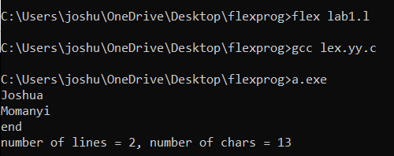

This is an automatic lexical analyzer that Count the number of characters and number of lines in the input using Flex